Name – Shubham Rajendra Gorade
Form No – 260605553

Q1 :-
Code
#include <iostream>
using namespace std;

class Student {
int rollNumber;
string name;
double percentage;
static int totalStudents;

Student() {
rollNumber = 0;
name = "";
percentage = 0;
toatalStudents=0;
}

Student(int roll, const string& studentName) {
rollNumber = roll;
name = studentName;
}

Student (const Student &obj1) {
cout<<"Copy constructor called";
}

void setPercentage(double percent) {
if(percent>=0 && percent<=100) {
percent = percentage;
}
}
double getPercentage() const{
return percentage;
}

char calculateGrade() const {
if(grade>=80) {
return "A";
}
else if(grade>=70) {
return "B";
}
else if(grade>=60) {
return "C";
}

else if(grade>=50) {
return "D";
}

else {
return "F";
}

}

~Student() {
cout<<"Destructor called";
}

}

int main() {
Student s1;
Student s2=s1;

return 0;
}

Output
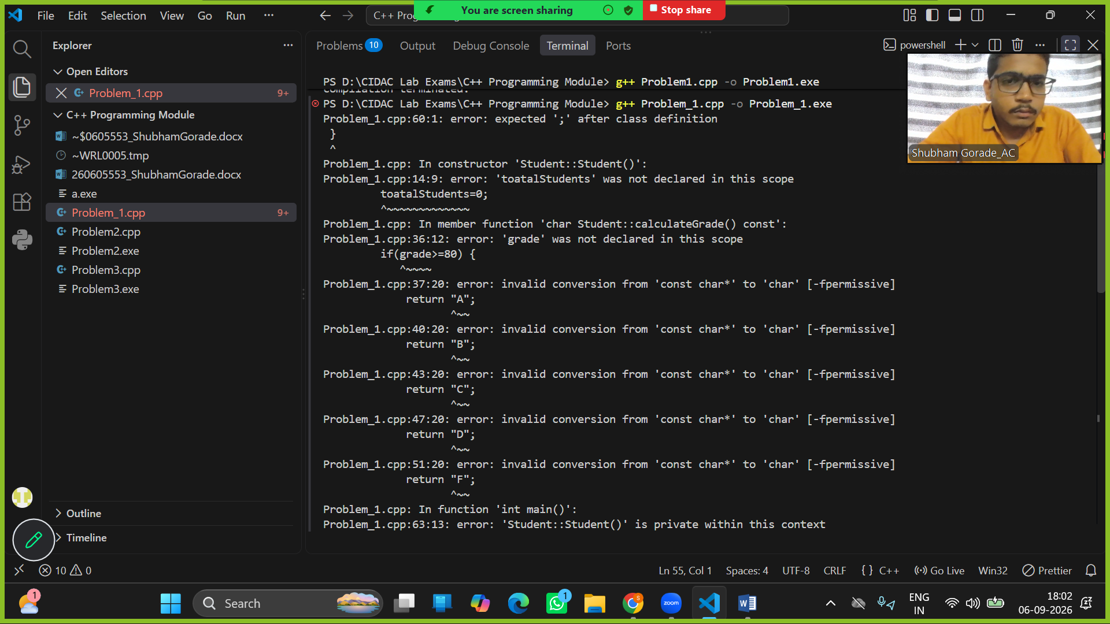
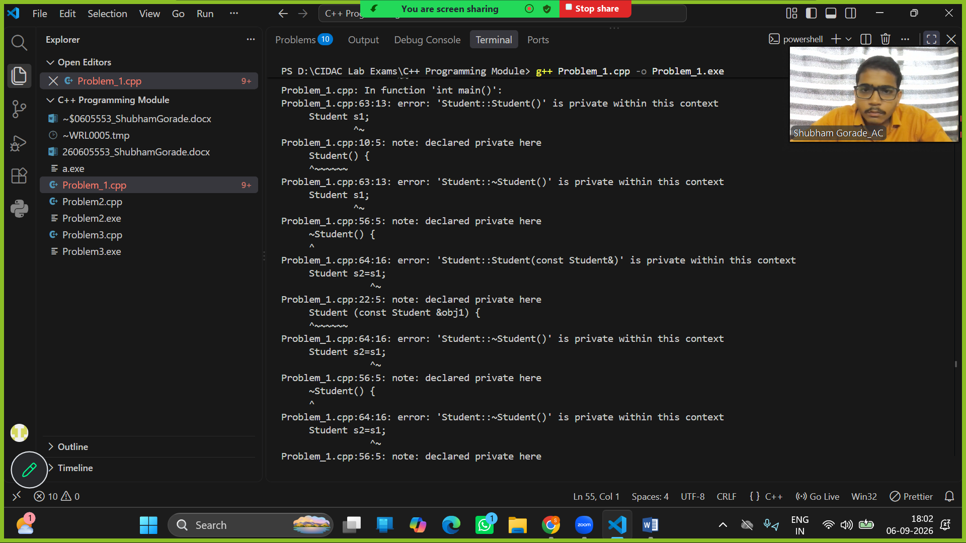

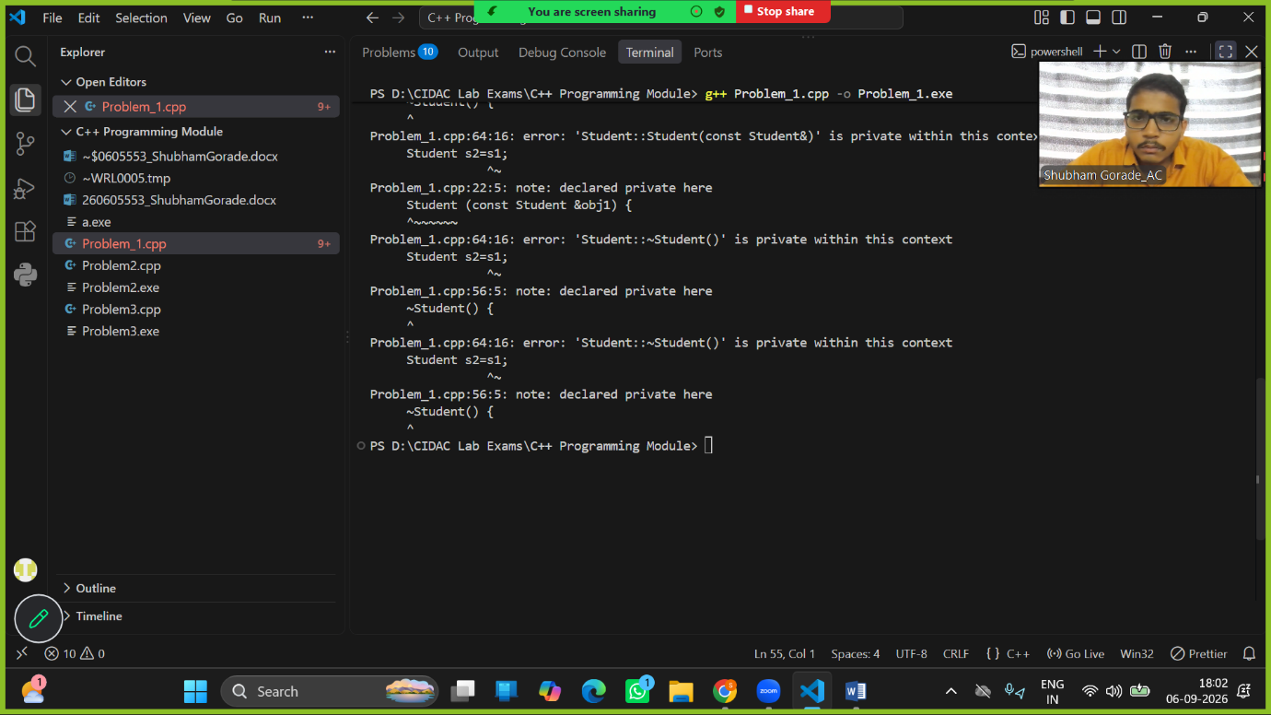

Q2:-
Code
#include <iostream>
using namespace std;

class Employee {
int empId;
string name;
double salary;
int performanceRating;

public:
Employee() {
int empId=0;
string name="";
double salary=0;
int performanceRating=0;
}

Employee (int id, const string& empName, double sal, int rating){
}

void accept() {
cin>>empId>>name>>salary>>performanceRating;
}

double calculateBonus() const {
if(performanceRating==1) {
return (salary*0)/100;
}
else if(performanceRating==2) {
return (salary*5)/100;
}
else if(performanceRating==3) {
return (salary*10)/100;
}
else if(performanceRating==4) {
return (salary*15)/100;
}
if(performanceRating==5) {
return (salary*20)/100;
}
else{
cout<<"Please enter valid reading in between 1 to 5";
return 0;
}
}

void displayDetails() const{
cout<<"ID: "<<empId<<" | Name:"<<name<<" | Salary: "<<salary<<" | Rating:"<<performanceRating<< " | Bonus: "
<<calculateBonus()<<endl;
}

};

int main() {
Employee obj[5];

for(int i=0; i<5; i++){
cout<<"Enter the details of the Employee :empId,name,salary,performanceRating"<<endl;
obj[i].accept();
}

for(int i=0; i<5; i++){
obj[i].displayDetails();
}
return 0;
}

Output
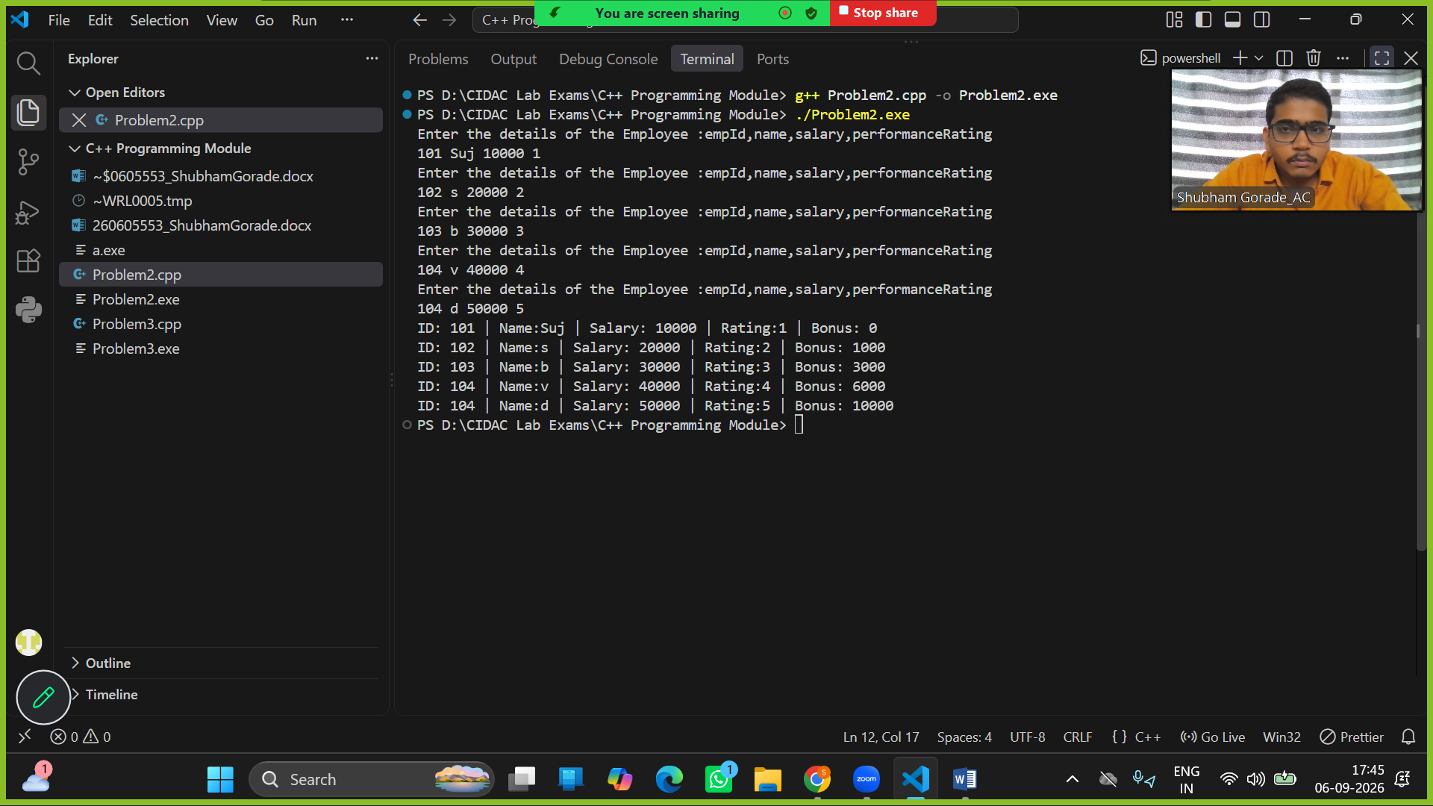

Q3:-
Code

#include <iostream>
using namespace std;

class Tempreture {
public :
double celsius;

Tempreture() {
celsius=0;
}

Tempreture(double cel) {
celsius=cel;
}

double toFahrenheit() const {
return (celsius*9/5)+32;
}

double toKelvin() const {
return celsius+273.15;
}

void displayAll() const {
cout<<"Tempreture :"<<celsius<<"C = "<<toFahrenheit()<<"F = "<<toKelvin()<<"K"<<endl;
}
};

int main() {

int tt1;
cout<<"Enter tempreture in celsius";
cin>>tt1;
if(tt1>=-273.15){
Tempreture t1(tt1);
t1.displayAll();
}
else {
cout<<"ERROR: Temperature below absolute zero (-273.15°C)";
}

int tt2;
cout<<"Enter tempreture in celsius";
cin>>tt2;
if(tt2>=-273.15){
Tempreture t2(tt2);
t2.displayAll();
}
else {
cout<<"ERROR: Temperature below absolute zero (-273.15°C)";
}

int tt3;
cout<<"Enter tempreture in celsius";
cin>>tt3;
if(tt3>=-273.15){
Tempreture t3(tt3);
t3.displayAll();
}
else {
cout<<"ERROR: Temperature below absolute zero (-273.15°C)";
}

int tt4;
cout<<"Enter tempreture in celsius";
cin>>tt4;
if(tt4>=-273.15){
Tempreture t4(tt4);
t4.displayAll();
}
else {
cout<<"ERROR: Temperature below absolute zero (-273.15°C)";
}

return 0;
}

Output

